**4.1 Gantt Chart (Semester 2)**

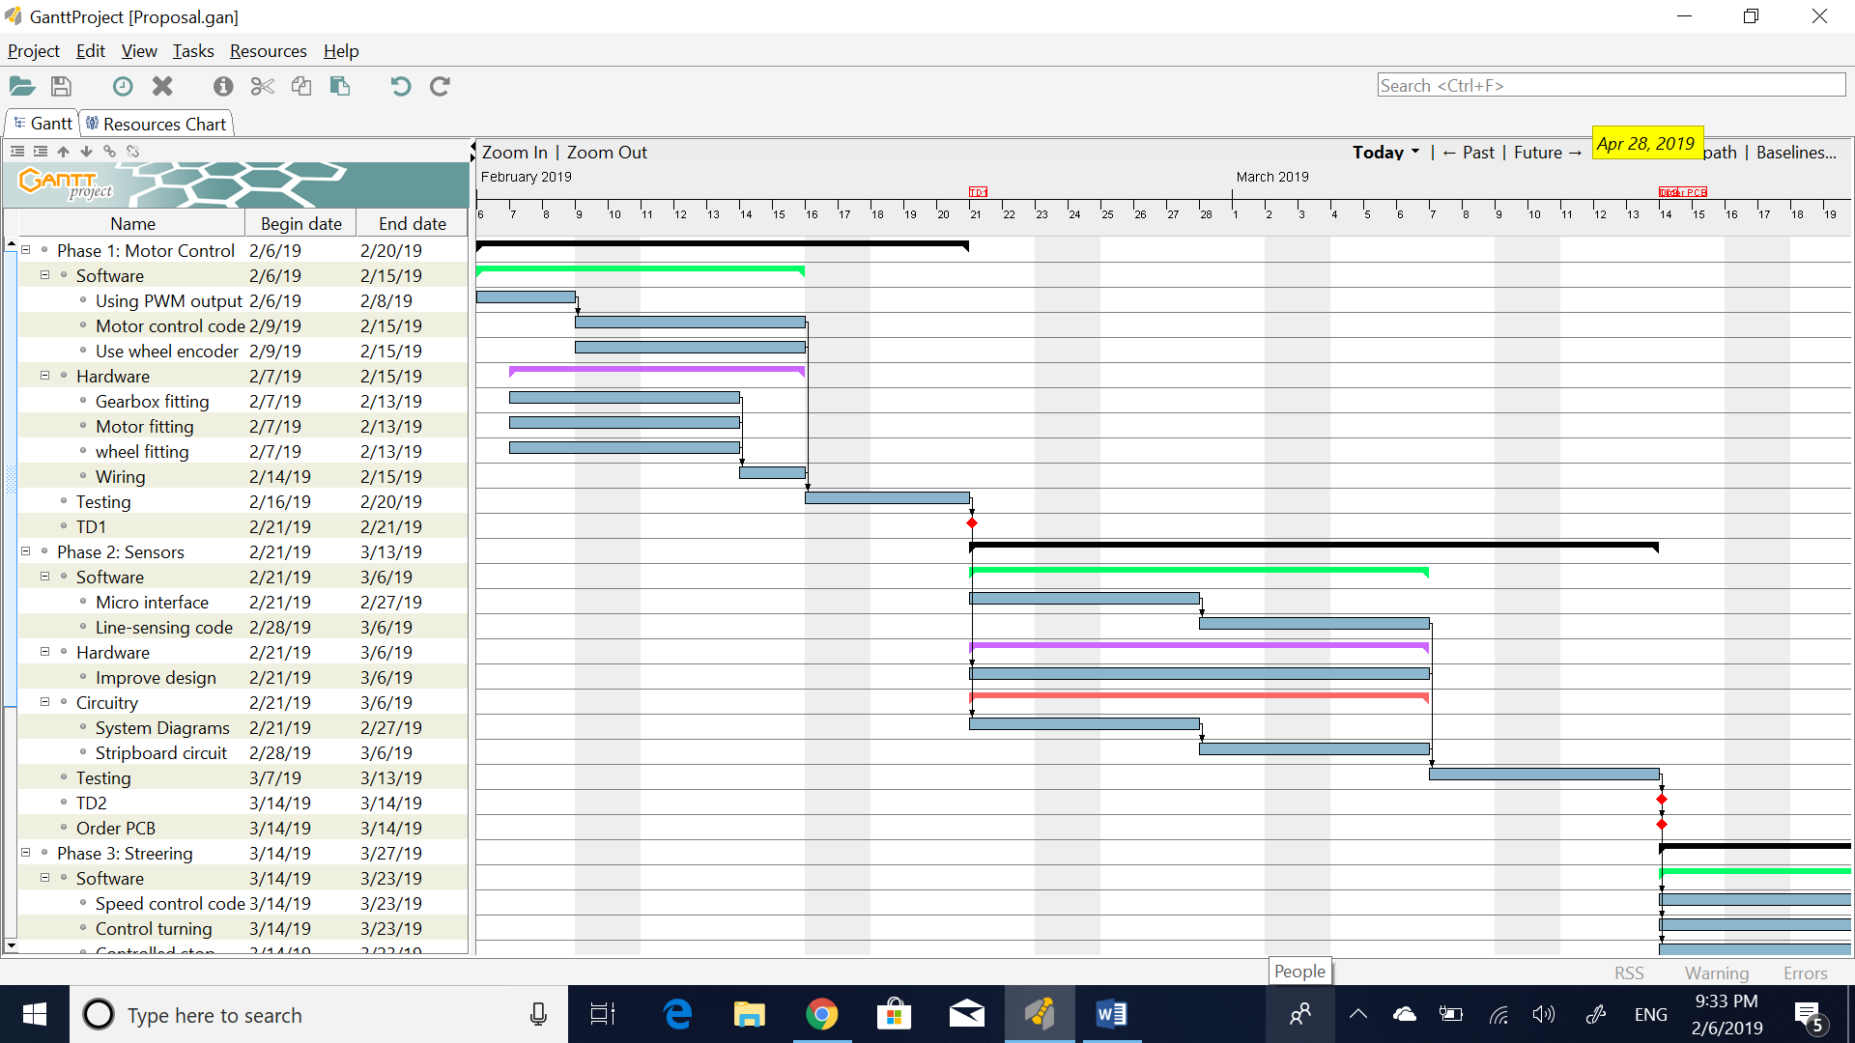

Figure 4.1 Phases 1 and 2 of Gantt chart

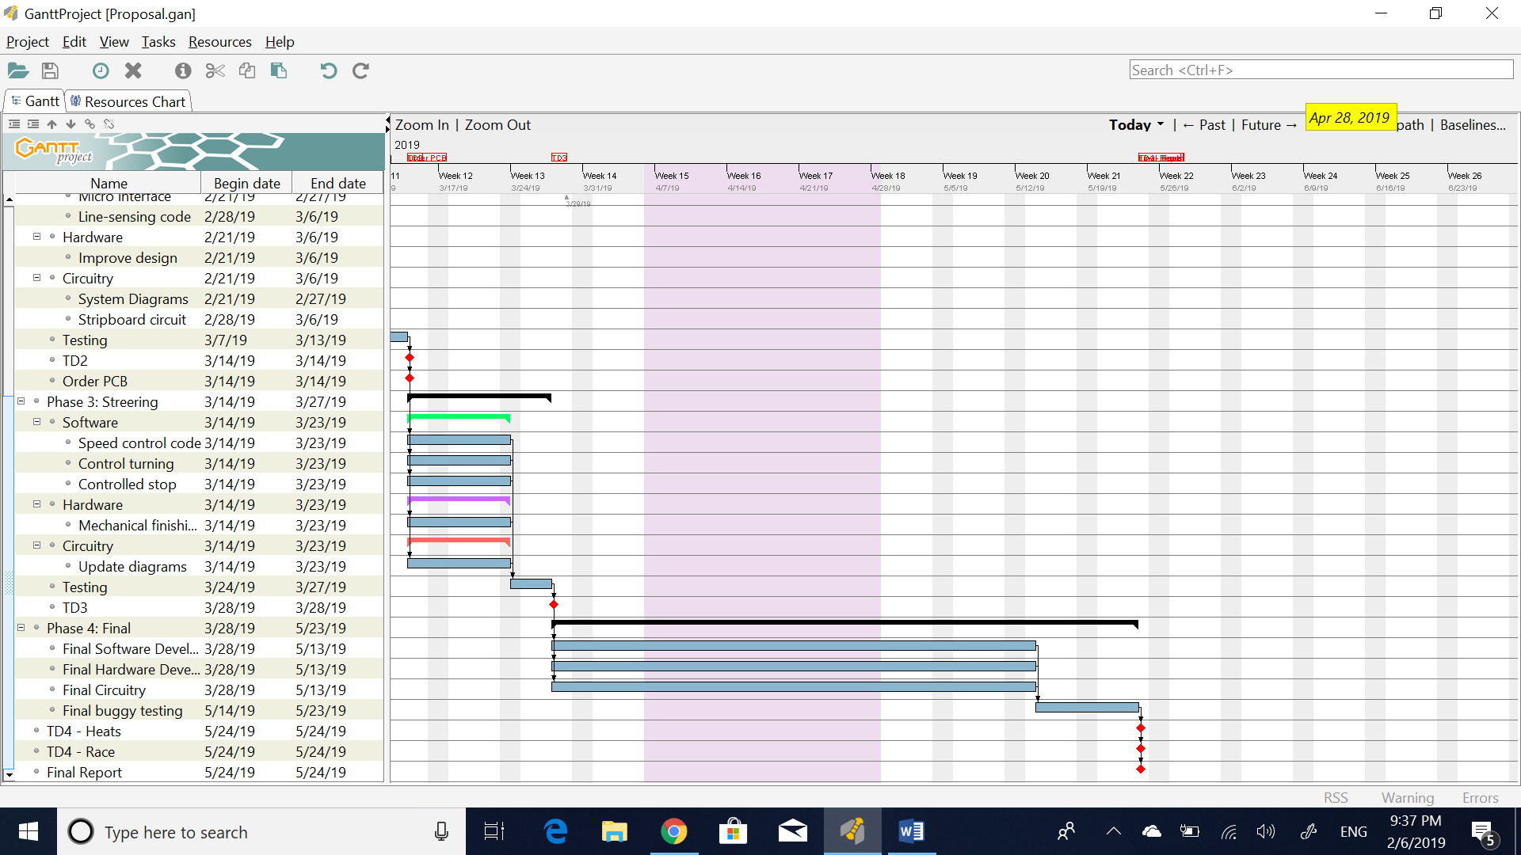

Figure 4.2 Phases 3 and 4 of Gantt chart

The project in semester 2 will be divided into four main phases. During each phase, a team of 2 members will be responsible for the software development, a team of 2 members responsible for the hardware development and a one member responsible for the circuitry. However, all members will be kept updated constantly during the phases ensuring coherence between software, hardware and circuitry. Phase 1 is mainly motor control where the buggy components are initially mounted on the chassis with PWM control being developed simultaneously. Phase 2 depends on phase 1 where the sensing circuit is developed based on the success of the tests on phase 1. Ordering of the PCB and components is done before the deadline, during phase 2 after the stripboard sensor circuit satisfies the requirements. Phase 3 initiates following the succession of phase 2 where the steering process is executed with the development of the controller required. The final phase is not executed until all first 3 phases are ended in which the complete buggy construction is finalised with the final program that can potentially finish the race successfully. To allow all system aspects to integrate, a testing section is included in each phase. The duration of the testing varies between 4 to 11 days depending on the phase. The testing also ensures contingencies are dealt with efficiently as the extra time offers enough room for error correction before the technical demonstration of each phase. Each technical demonstration must result in satisfaction to proceed with the project.